**Manager Pickup and Delivery Management**

Pickup and Delivery(P&D) management is the core , the main purpose of the project. It allow manager to receive customer P&D request, view useful information for available Employees and Requests for decision making, changing the price for requests and then allocate request to Employee according to request specification and efficiency of delivery.

Below shows step on completing the task [Code available and “M P&D Manage Code” Folder]:

1. In order the perform the function, I need to make some changes to Pickup (customer request) table. Which by add in customer_Id (foreign-key), (pickup)employee_id (foreign-key), deliveryemployee_id (foreign-key) to table to identify request customer identity, and employee responsible to handle request pickup or delivery for request allocation.

Rails provide user to generate migration with command : “$rails generate migration edit_request_for_management”

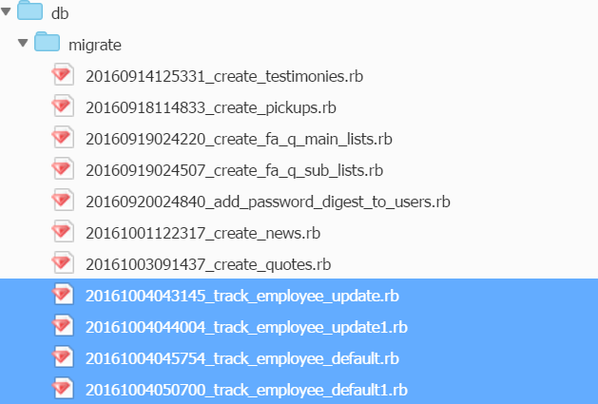

Rails migration file related to M P&D Management

1. After add in the modification code into migration file, run “$rake db:migrate” to update the changes.
2. I add in the function into the exist “users.show” html created at previous release.



If else statement in “users.show” that transfer manager to manager portal if identify login user [identity =”manager”]

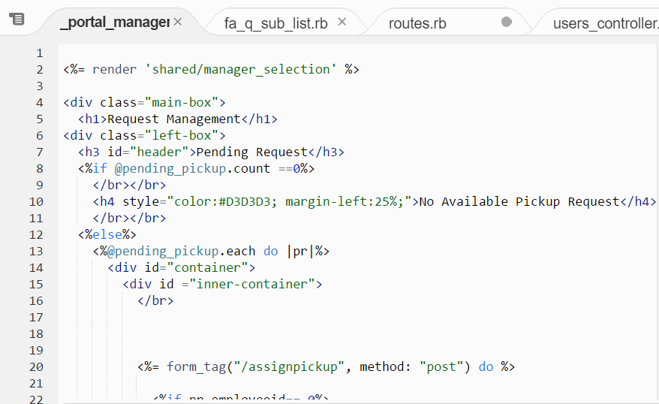

Manager Main Portal that handling component to perform M P&D management function

1. Several function need to be created to perform the task. Required function are:

* Assign Pickup (Assign request pickup to employee)
* Assign Delivery (Assign Request delivery to employee)

Below shows how to create controller function in Ruby on Rails :

1. Create respective route in routes.rb :

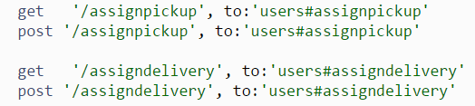

1. Create the function in controller :

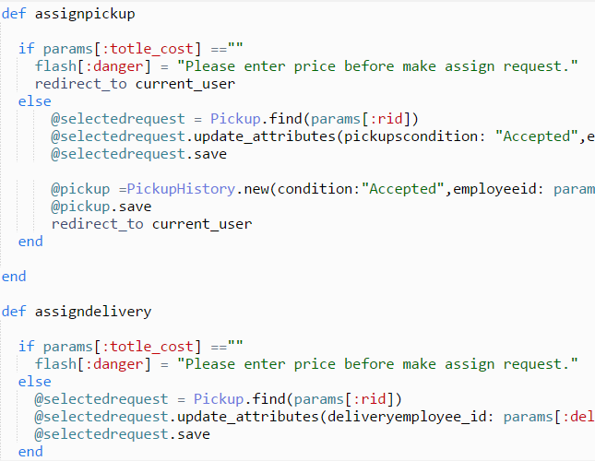

1. Create a form_tag to submit updates to function:

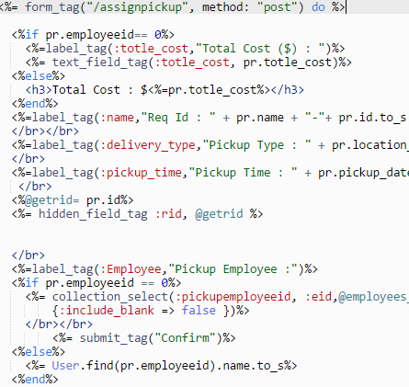

1. Include CSS for user interface design.

